# Background

The code began to throw errors due to unambiguous formatting on index string:

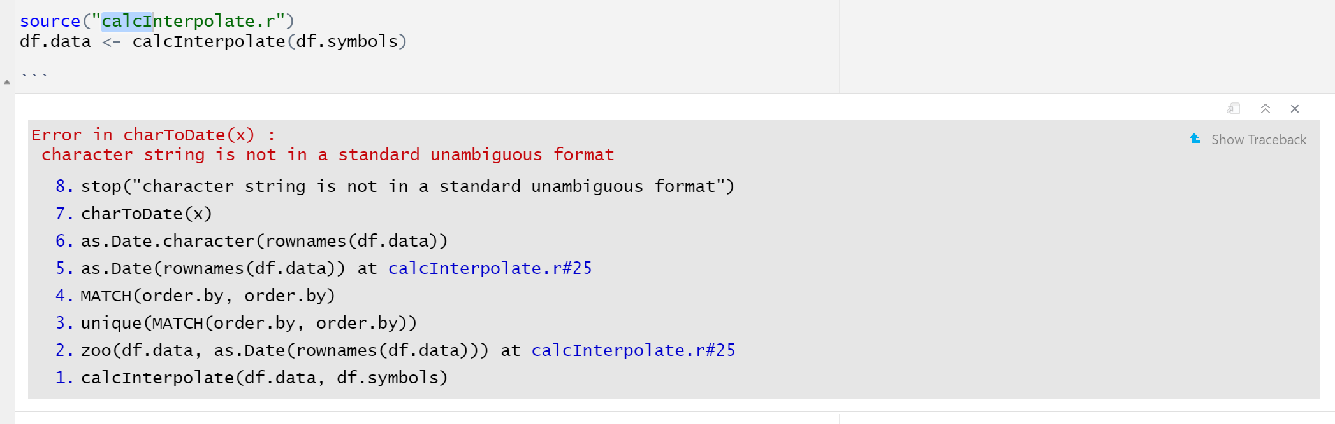

I performed some root cause troubleshooting and found that for some symbols the getSymbols command returned duplicate dates:

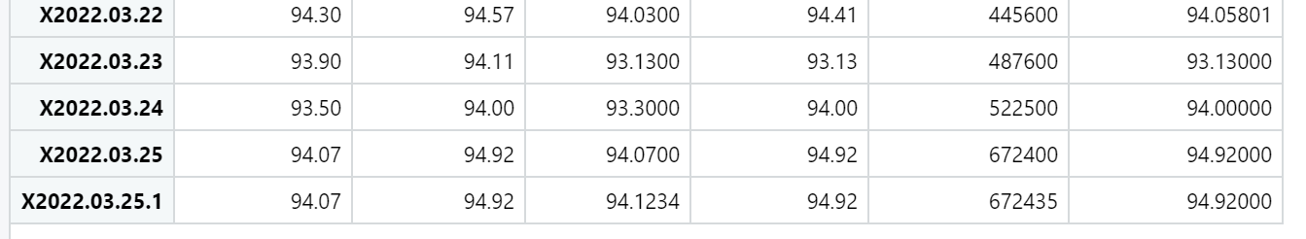

# Solution

I found this StackExchange [write-up](https://stackoverflow.com/questions/8865257/remove-duplicate-rows-from-xts-object)Revision X in date.docx explaining how to remove duplicate rows. I tested the fix on a single symbol, NOBL. The command is

NOBL <- NOBL[ ! duplicated ( index(NOBL)),]

With the results:

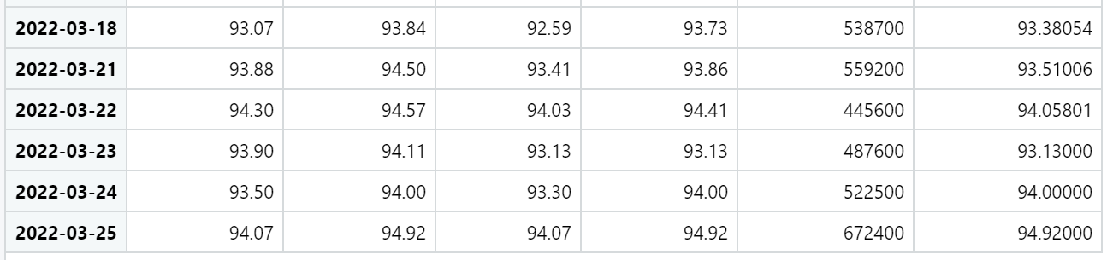

Took some research, but looks like I can programmatically assign using this code

assign(df.symbols$string.symbol[18], get(df.symbols$string.symbol[18])[ ! duplicated ( index(get(df.symbols$string.symbol[18]))),])

This StackExchange [article](https://stackoverflow.com/questions/2679193/how-to-name-variables-on-the-fly) had some good insight on how to use assign.